

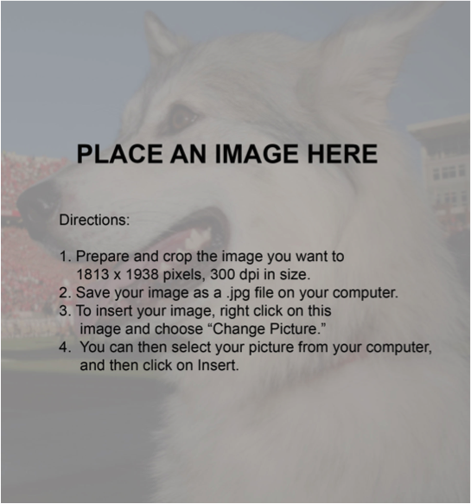

## Title of Event

## Event Detail

## Date

## Time

# Get Started Right Away

If you’re ready to write, just select a line of text and start typing to replace it with your own.

Use Heading 1 for Title  
You can replace this text with more details and information about the event.

# Information

Location Details

Location Address

More information

# I**nformation**

For best results when selecting text to copy or edit, don't include space to the right of the characters in your selection.

# More information :

http://cnr.ncsu.edu/event